Python Module
Modules are used to categorize Python code into smaller parts. A module is simply a Python file, where classes, functions and variables are defined. Grouping similar code into a single file makes it easy to access. Have a look at below example.
If the content of a book is not indexed or categorized into individual chapters, the book might have turned boring and hectic. Hence, dividing book into chapters made it easy to understand.
In the same sense python modules are the files which have similar code. Thus module is simplifying a python code where classes, variables and functions are defined.

Python Module Advantage
Python provides the following advantages for using module:
- Reusability: Module can be used in some other python code. Hence it provides the facility of code reusability.
- Categorization: Similar type of attributes can be placed in one module.

Importing a Module
- Using import statement:
"import" statement can be used to import a module.

Syntax
Import file_name1, file_name2,………, file_name n

Example
Create a file addition.py in a folder and write down the code below in it.
Create another python file in which you want to import the above python file.
- Using from .. import statement:
From .. import statement is used to import particular attribute from a module. In case you do not want whole of the module to be imported then you can use from import statement.
Create a File with name area.py and write down the code below

Create another file of your desired name and run the code below

- To import whole module
You can import whole of the module using " from import * "
We will work with the same file area.py you created above.

Create another file of your desired name and run the code below

Built-In Modules
There are many built in modules in Python. Some of them are as follows:
math, random , threading , collections , os , mailbox , string , time , tkinter etc..

- Math
Using math module , you can use different built in mathematical functions.
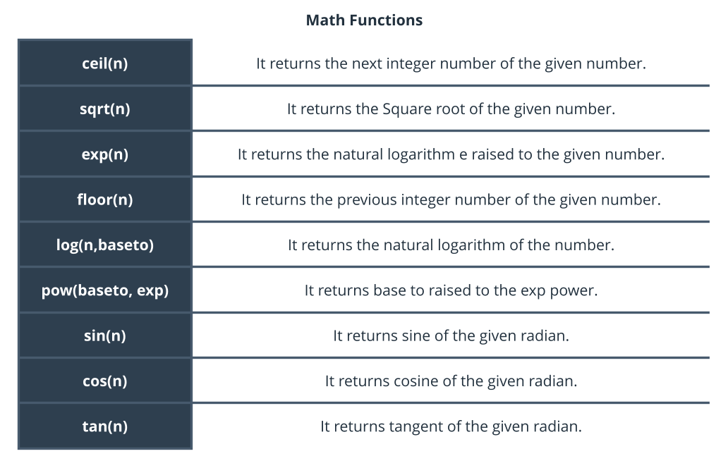
Example of using Math Module

- Random:
The random module is used to generate the random numbers. It provides the following two built in functions:
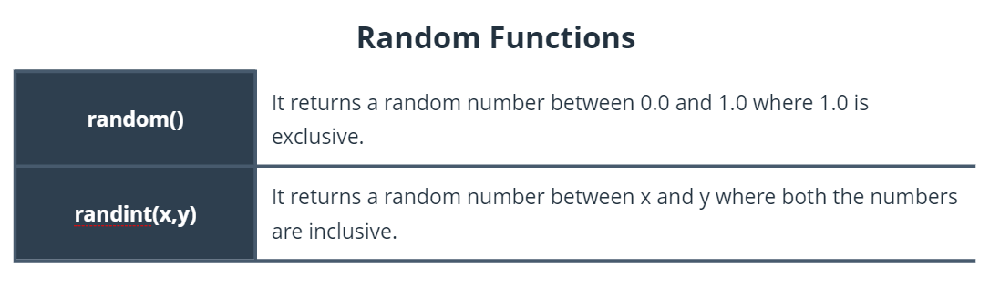

Example

